**STOCK PERFORMANCE ANALYSIS**

**OBJECTIVE:**

The goal of this project is to track the performance of Stocks of 5 companies (IBM, Microsoft, Telsa, Amazon, Google) using comprehensive Dashboard. The data fetched is using **Alpha Vantage API**. This dashboard will provide insights into stock price trends and stock price metrics. This project integrates data extraction, transformation, and visualization to help analyzing stock performance.

**PROJECT COMPONENTS AND TOOLS USED:**

1. **Data Extraction**:
   * Use the **Alpha Vantage API** to fetch **historical stock data** for five key U.S. companies: **Amazon (AMZN), Google (GOOGL), Microsoft (MSFT), IBM (IBM), and Tesla (TSLA)**.
   * The data will include **open**, **close**, **high**, **low**, and **volume** and Moving average for the last 2 years (till January 29, 2025).
   * The Data is Extracted using Python code Following the Documentation of the API.
2. **ETL Pipeline**:
   * Build an **ETL (Extract, Transform, Load)** pipeline using **Python**.

**Extract**: Pull stock data from the Alpha Vantage API.

|  |  |
| --- | --- |
| Features | Meaning |
| Open | The Price of the stock at the beginning of the trading day |
| Close | The Price of the Stock at the end of the Trading Day |
| Volume | The Total Number of Shares Traded during the day |
| High | The Highest Price the stock reached during the trading day |
| Low | The Lowest Price the Stock reached during the trading day |

**Transform**: Calculate additional metrics such as **Price Change, Price Range, Average Price and Volatility. (Feature Engineering)**

**1. Price Change**

Price change measures the difference between the closing price of a stock on two consecutive trading days. It indicates whether the stock price has increased or decreased.

**Formula:**

**Price Change=Close Price (Today)−Open Price (Today)**

* A **positive price change** means the stock price has increased.
* A **negative price change** means the stock price has decreased.
* Larger values indicate more volatility in stock movement.

**2. Price Range**

Price range refers to the spread between the highest and lowest price of a stock during a trading session. It helps understand the daily volatility of the stock.

**Formula:**

**Price Range=High Price−Low Price**

A **larger price range** suggests higher intraday volatility.

A **smaller price range** suggests a stable price movement.

**3. Average Price**

The average price provides a simple representation of the stock price over a given period, making it useful for trend analysis.

**Formula:**

**Average Price=(High Price+Low Price + Close Price)/3**

* This metric helps smooth out price fluctuations and gives an approximate value of how the stock has been trading.
* It is often used in technical analysis to determine the fair value of a stock on a given day.

**4. Volatility**

Volatility measures how much the stock price fluctuates over a given period. It indicates the level of risk or uncertainty in the stock's price movement.

**Formula:**

**(Daily Volatility):**

Volatility= (High Price−Low Price)/ Close Price×100.

Used some common Libraries like Pandas, Matplotlib, Seaborn For EDA Analysis.

**Load**: Store the cleaned data in a **SQL database** and **Power BI.**

1. **SQL Database**:
   * Set up a **SQL database** to store the historical stock data.
   * Create a schema to organize stock prices and other metrics in different tables.
   * Use **SQL queries** to perform aggregations, averages, and other performance metrics.
2. **Power BI Dashboard**

* Created Date Table Column from Date Column from stock market data and extracted - Year, Month, Week Number, Day Number, Weekend/Weekday.
* Creating Key Visuals in Power BI
* Created **KPI visuals** for **Close, Open, and Volume** to monitor stock performance.
* Used DAX to show: **Previous Day, Previous Month, Previous Week, and Year Comparisons** andMonth-on-month **percentage change** in stock prices.

**Entity Relationship & Data Modeling**

* **Created a Relationship** between the **Date Table** and Stock Data using Date as a key.
* This helps in **time-based analysis and filtering**.

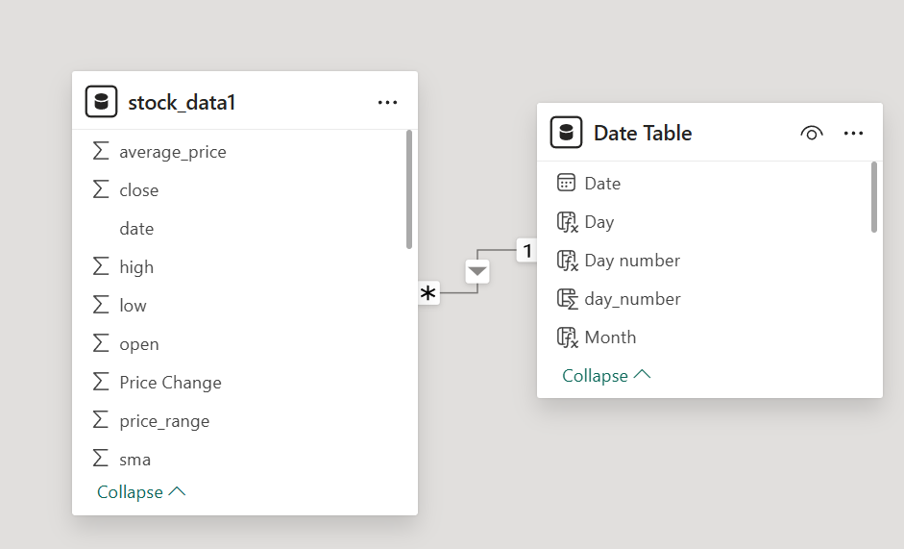

* **Slicers for Filtering**
* Added **slicers for Month, Year, and Date**, so users can choose specific time periods.
* This allows **dynamic filtering** of stock data.
* Calculated **stock volatility** using the standard deviation of stock prices.
* Identified **which stock fluctuates the most**
* Created a **Pie Chart** to compare **trading volume across stocks**.
* Helped visualize which stock is **traded the most**.